## 1. Basic SSH Concepts

- What is SSH, and why is it preferred over Telnet?

SSH (Secure Shell) is a cryptographic network protocol for secure remote login and command execution.
- What is the default port number used by SSH?
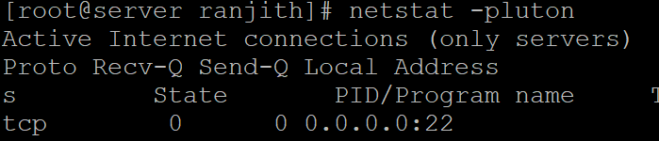
- What is the purpose of the `sshd` service in Linux?
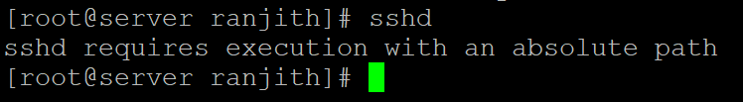
sshd is the SSH daemon that listens for incoming SSH connections and handles authentication and session management on the server side.

- How can you check whether the SSH service is running on a Linux system?
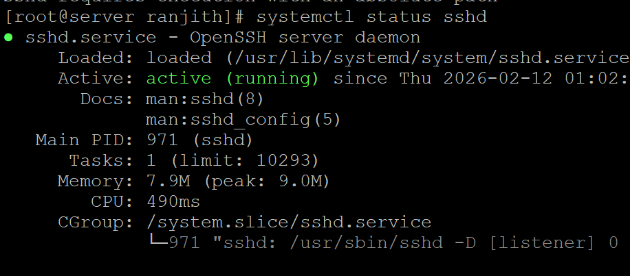
- What is the difference between an SSH client and an SSH server?
An SSH client is the tool (e.g., ssh) used to initiate connections to a remote system. An SSH server (sshd) runs on the remote system and accepts incoming connections.

---

## 2. SSH Commands & Usage

- Write the command to connect to a remote server using SSH.
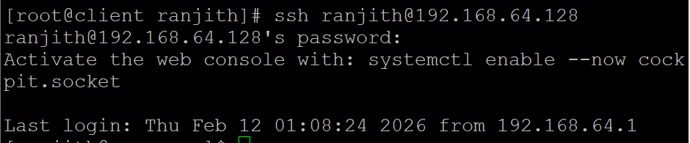
- How do you specify a custom port when connecting via SSH?
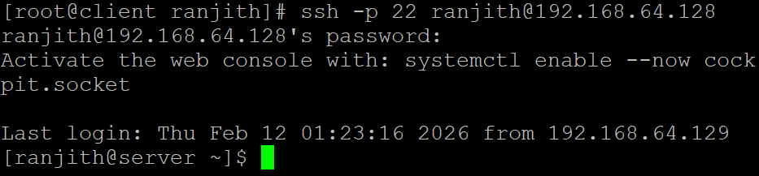
- How can you log in as a specific user using SSH?
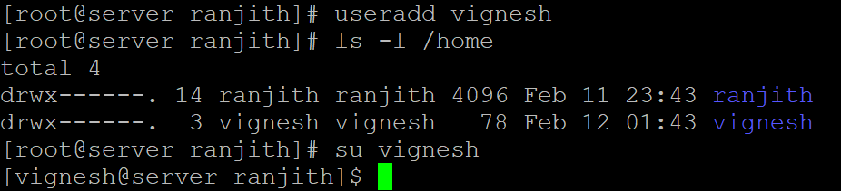
- What is the purpose of the `-i` option in the `ssh` command?
-i specifies the identity (private key) file to use for public‑key authentication.
10. How can you execute a single command on a remote server using SSH without opening an interactive shell?
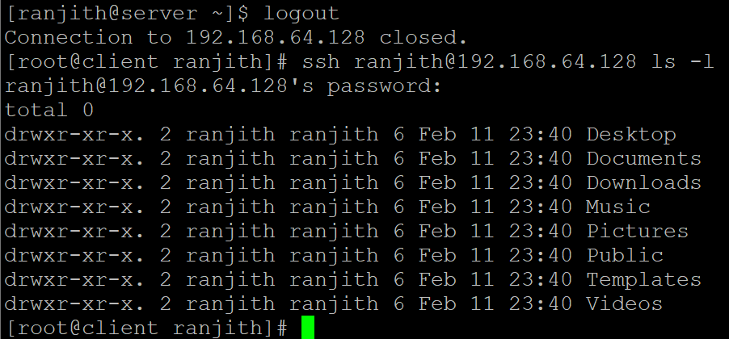
## 3. SSH Keys & Authentication
11.What is the difference between password-based authentication and key-based authentication?
Password auth uses a user‑supplied password that is sent (encrypted) to the server. Key‑based auth uses a cryptographic key pair; the private key proves identity without transmitting a password.
12.Which command is used to generate an SSH key pair?
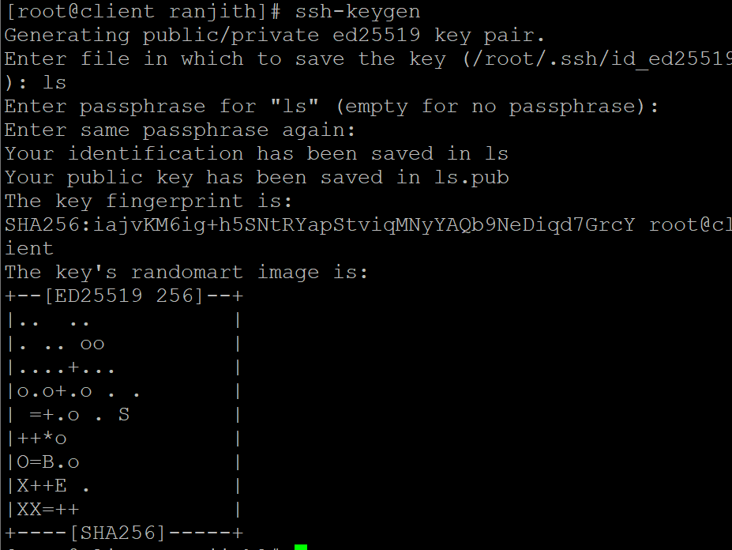
13.Where are SSH keys stored by default on a Linux system?
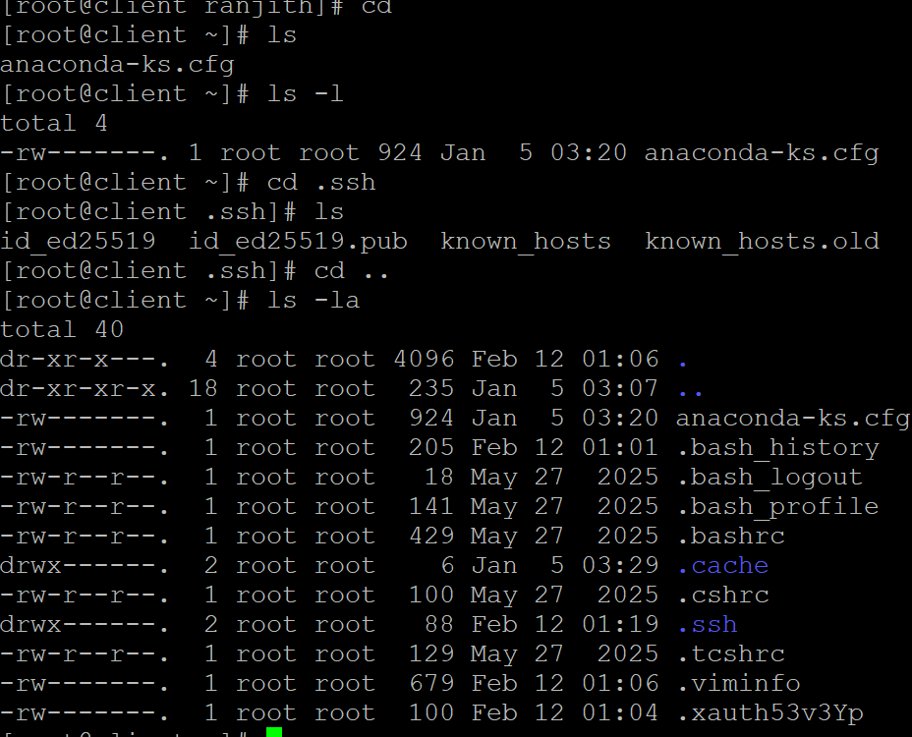
14.What is the purpose of the `authorized_keys` file?
It holds the public keys that are allowed to log in to the associated user account via key‑based authentication.
15.How do you copy your public SSH key to a remote server?
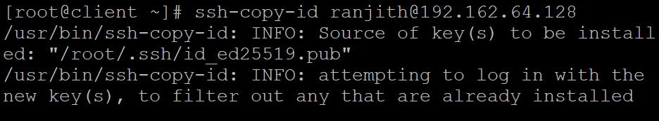

---

## 4. SSH Security & Configuration

16. Which configuration file is used to configure the SSH server?
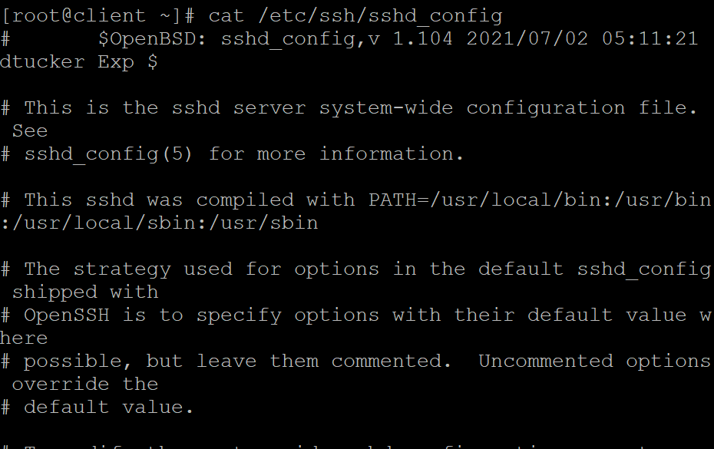
17. How do you disable root login via SSH?
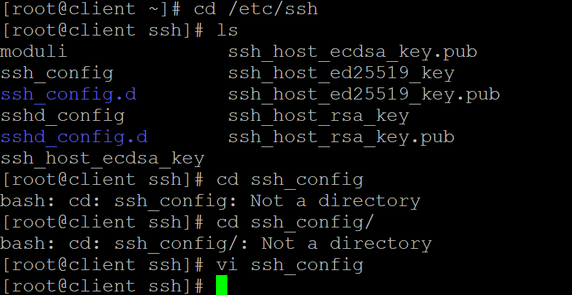
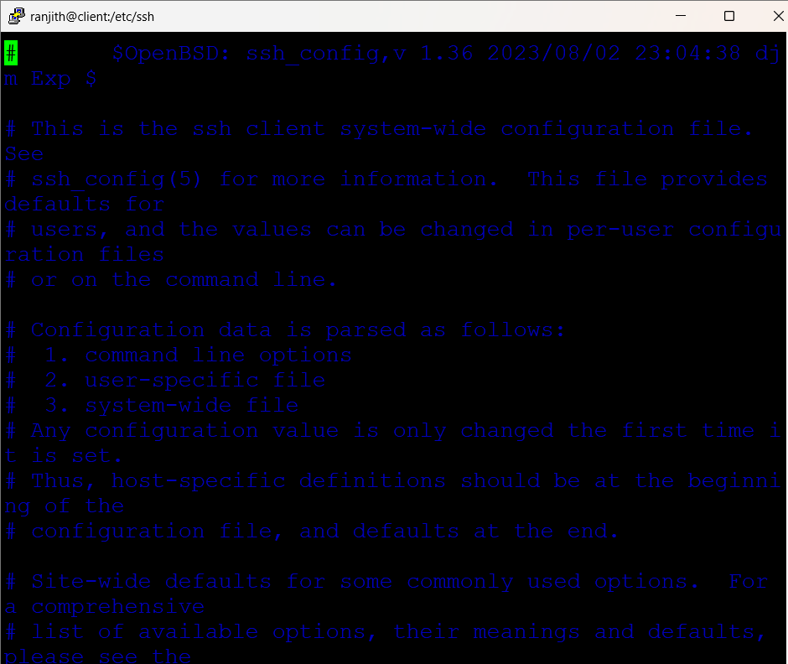
18. How can you restrict SSH access to specific users only?
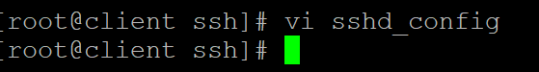
19. What steps would you take if an SSH connection is timing out?
- Check network connectivity.
- Verify the SSH server is running.
- Confirm firewall rules allow the SSH port.
- Increase client timeout with ssh -o ConnectTimeout=<seconds>
20. Why is it recommended to disable password-based authentication in SSH?
It reduces risk of brute‑force attacks; key‑based auth provides stronger cryptographic security

